Assignment -3
Python Programming

Question-1:

Write a python code for led blinking in raspberry pi

SOLUTION:

import RPi.GPIO as GPIO # Import Raspberry Pi GPIO library

from time import sleep # Import the sleep function from the time module

GPIO.setwarnings(False) # Ignore warning for now GPIO.setmode(GPIO.BOARD) # Use physical pin numbering

GPIO.setup(8, GPIO.OUT, initial=GPIO.LOW) # Set pin 8 to be an output pin and set initial value to low (off)

while True: # Run forever

GPIO.output(8, GPIO.HIGH) # Turn on

sleep(1) # Sleep for 1 second

GPIO.output(8, GPIO.LOW) # Turn off

sleep(1) # Sleep for 1 second
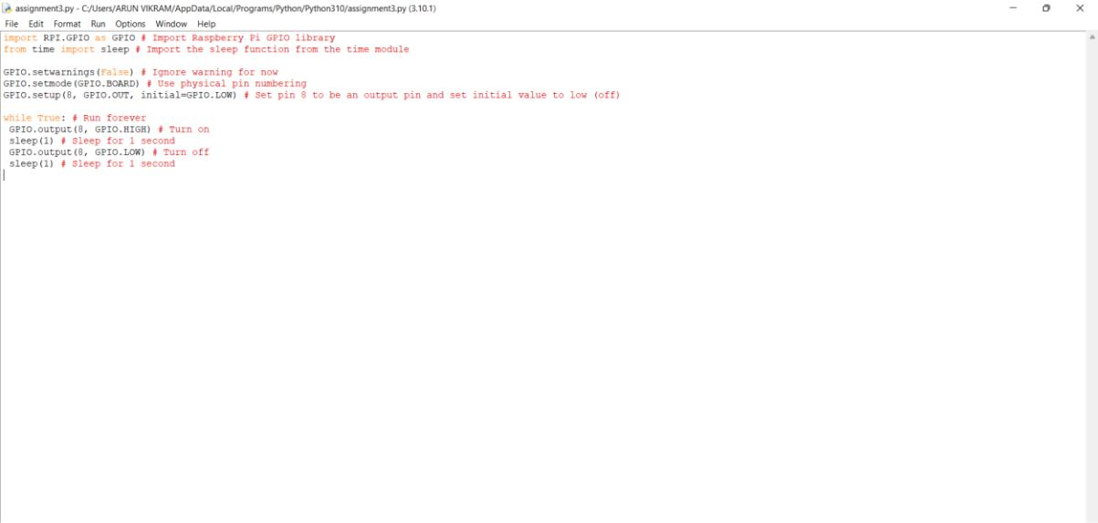

Question-2:

Write a python code for traffic light in raspberry pi

SOLUTION:

from gpiozero import Button, TrafficLights, Buzzer from time import sleep

buzzer = Buzzer(15)

button = Button(21)

lights = TrafficLights(25, 8, 7)

while True:

button.wait_for_press()

buzzer.on()

light.green.on()

sleep(1)

lights.amber.on()

sleep(1)

lights.red.on()

sleep(1)

lights.off()

buzzer.off()
